**Purified Images User Manual**

The user will initially see the home window.

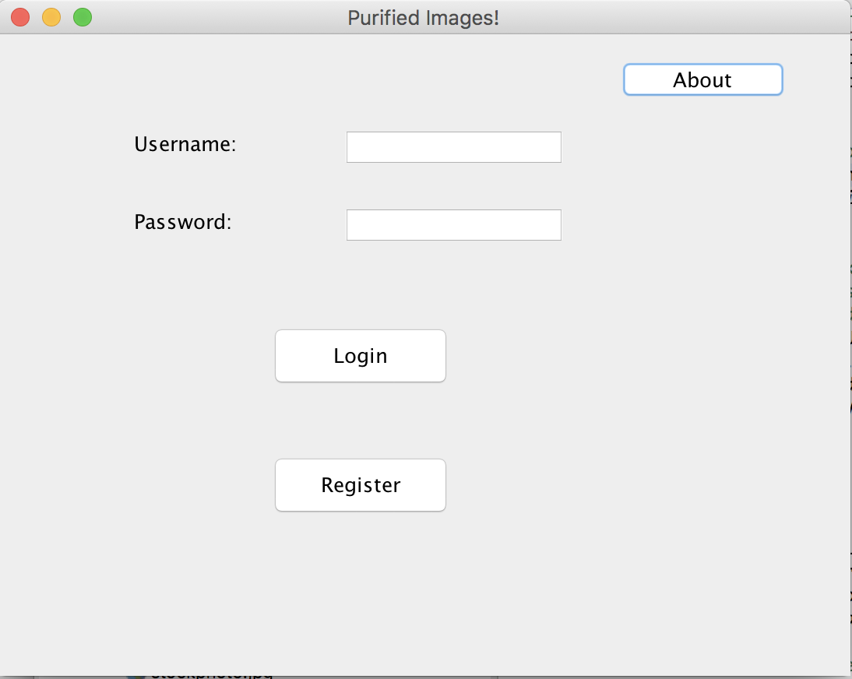

Existing users can login to the application directly by entering their username and password and clicking on the “Login” button. A first-time user will need to register before they can use the application. To do this, click on the “Register” button. This opens the registration window.

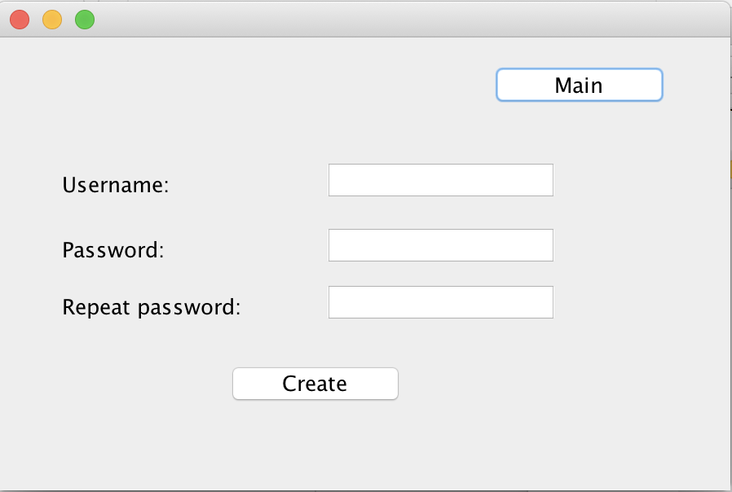

A successful registration will be acknowledged.

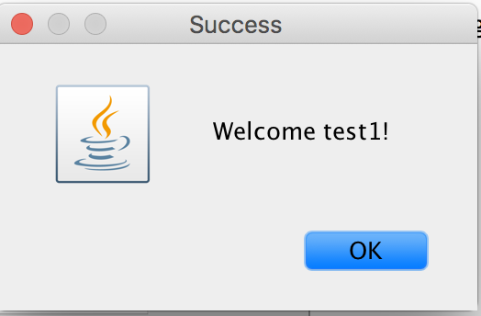

The user is then returned to the home window.

If an invalid username/password combination is entered at login, the user is notified.

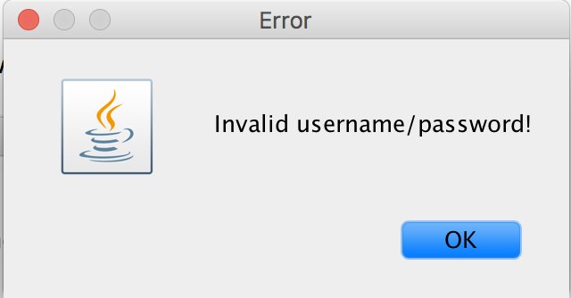

Once the user is logged in successfully, they will see the main application window.

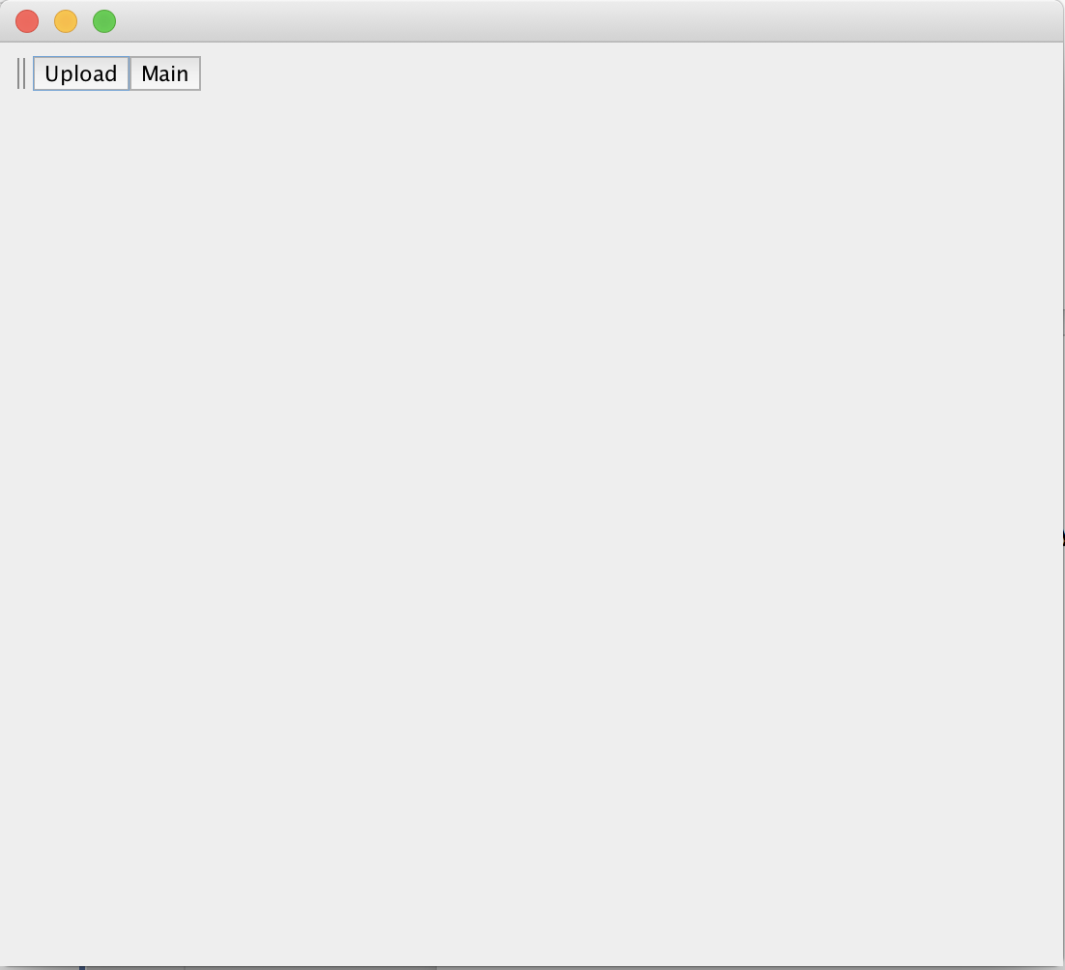

When no images have been uploaded, there will be two buttons available, one to upload an image and the other to return to the home window. To use, the application, click on the Upload button and select the file to upload. You will be asked to name the file, then see it displayed on the main application window, shown on the next page.

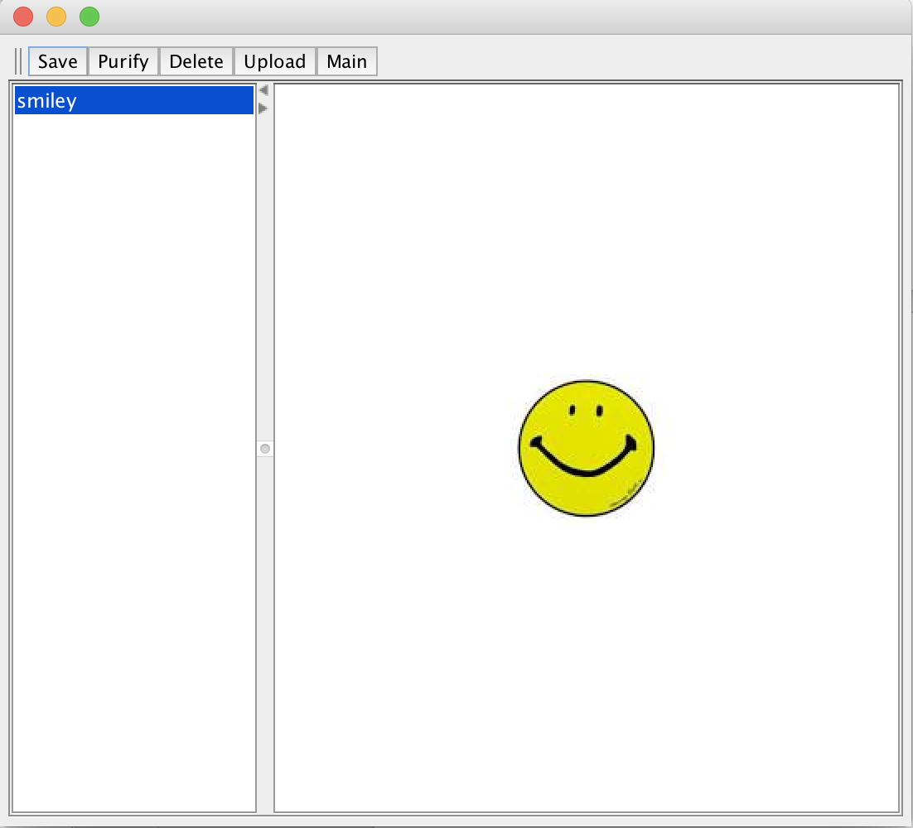

Once a file has been uploaded, you will now see the other button functions, Save, Purify, and Delete. Save will save the image in its current status to the host computer. Purify will render the image in black and white. Delete will delete the image form the application database. The window on the next page shows what appears after an image had been purified.

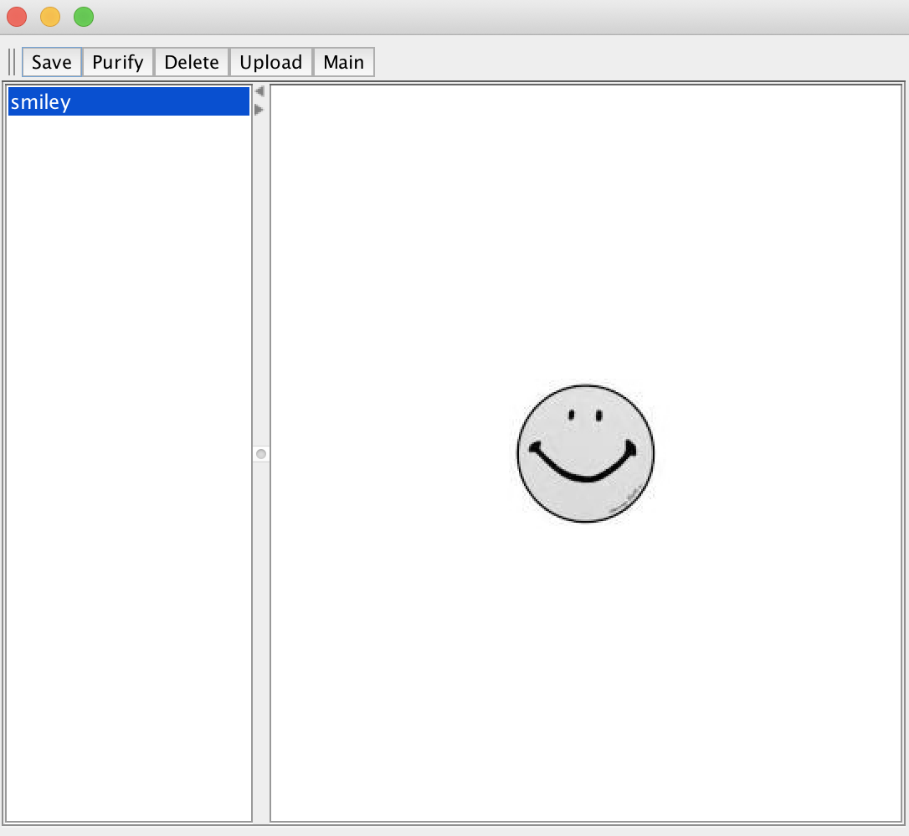

The About window, accessed from the home page, displays application information.

